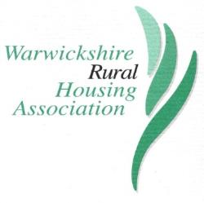

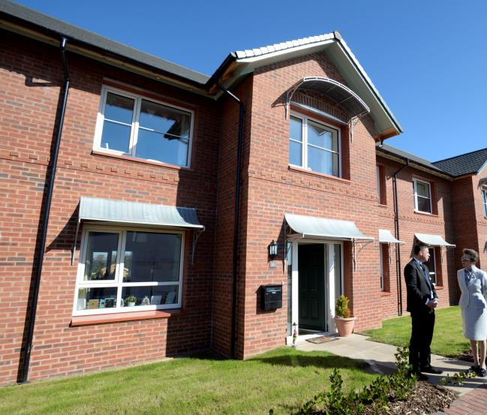

Warwickshire Rural Housing Association

Board Member Recruitment Pack 2020
Tel: 0300 1234 009
Website: www.warwickshirerha.org.uk
Twitter: @WarksRural

BOARD MEMBER RECRUITMENT PACK

CONTENTS

1 WELCOME LETTER Page 2

2 ABOUT WRHA Page 3

3 ROLE PROFILE Page 4

4 RECRUITMENT TIMETABLE Page 7

5 OTHER INFORMATION Page 8

6 HOW TO APPLY Page 9

APPENDICES

1. Provisional Meeting schedule 2021 Page 10
2. Board Member Terms of Reference Page 11
3. Recruitment advert Page 13
4. Recruitment press release Page 14
5. Application form Page 16
6. Diversity monitoring form Page 20

1 WELCOME LETTER

Thank you for your interest in joining the Board of Management at Warwickshire Rural HA. When you have read the information available and you feel that you could have a contribution to make, then I hope you will allow us to consider your application.

We are a specialist Housing Association, fiercely independent but working with many partners to deliver affordable and social housing within the rural communities of Warwickshire. We are passionate about what we do. We have built a strong reputation over the last 30 years of helping to maintain the sustainability of those communities and serve our residents well. We provide well-built homes, for local people, in keeping with local architectural styles and local choices. We are committed to supporting our residents and to increasing our engagement with them.

We aim to build a balanced Board and have a number of skills shortages, shown up by our recent Skills Audit. We do not expect you to have everything, and for the right people we can provide induction into how we operate, in partnership with Midlands Rural Housing, and how we actually work with local agencies.

If you would like to speak to me about the Association, then please feel free to contact me via the Company Secretary, Richard Mugglestone on 0300 1234 009 or richard.mugglestone@midlandsrural.org.uk. You may also wish to speak directly to Richard about our work.

Yours sincerely,

Ruth

Ruth Bagley
Chair of Warwickshire Rural Housing Association

2 ABOUT WARWICKSHIRE RURAL HOUSING ASSOCIATION

The vision of WRHA can be summarised as follows:

“Good quality, well-managed affordable homes;
vibrant communities across rural Warwickshire.”

Warwickshire Rural Housing Association manages 584 homes, with further dwellings in development. Despite the challenging economic and fiscal environment, we remain committed to delivering our vision. The Association works with rural communities to keep Warwickshire’s villages alive by providing much needed affordable homes for those with a local connection. Homes are at the heart of rural life and WRHA works with partners to carry out the vital work of building homes and communities.

The Association’s strategic and business objectives are to:

- Engage effectively with our residents

- Maintain our stock in good condition and invest to meet modern standards of quality, affordability and environmental sustainability

- Provide high quality housing management services

- Provide new affordable homes for the benefit of people who need to live or work in rural areas

- Innovate to achieve lower running costs for our residents and lower delivery costs in construction and environmental efficiency

- Strengthen and grow partnership arrangements with local authorities, developers, financial organisations and other stakeholders

In support of these objectives we will:

- Maintain a viable and well-managed business and enable re-investment in our objectives, through:

- Sound financial management
- Compliance with regulatory and governance requirements
- Understanding of our residents’ needs and aspirations
- Motivating, developing and recruiting a skilled and committed staff team and board

The Association has shown itself able to cope with the pressures of Covid-19 and maintain a good quality of service to residents. We are confident of our sustainability and are now reviewing our Strategy to ensure it remains fit for the new environment.

Further detail on how Warwickshire Rural Housing Association delivers its aims can be found in the Strategic Plan and wider information is available on the website.

3 ROLE PROFILE

Job title: Board Member

Responsible to: Chair

Overall purpose

The primary role of the Board is to ensure excellence in governance, support the executive team to manage the business and maintain its financial viability.

As a board member you will be working with a team of talented and respected professionals deciding the strategic direction of the Association, including setting and monitoring the annual business plan and budget.

You will represent WRHA and ensure that the board is fully accountable to the residents, stakeholders and communities it serves for the decisions it has taken and actively engages with them to demonstrate this accountability.

Board Member Role Description

Key Responsibilities

As a member of the Board of Management

- To oversee and set the long-term strategic direction for the organisation in support of the Association’s business plan.

- To ensure that the Board fulfils its duties and responsibilities for the proper governance of the organisation, including compliance and risk management.

- To ensure that performance is monitored and managed through an appropriate system of internal controls and delegation.

- To approve key policies to allow the organisation to achieve its objectives.

Duties and tasks to fulfil the key responsibilities

- To oversee and set the long-term strategic direction for the organisation

- To collectively set the strategic objectives and high-level policies for the organisation
- To uphold and promote the core policies, purpose, values and objectives of the Association
- To ensure major risks are reviewed regularly and that an effective risk management framework is maintained
- To keep abreast of current developments and thinking in the sector

- To ensure that the Board fulfils its duties and responsibilities for the proper governance of the organisation, including compliance

- To act reasonably and always in the best interests of the organisation, and comply with its code of conduct
- To contribute to and share responsibility for decision of the Board
- To work in partnership with the Company Secretary and Senior Managers, and to challenge colleagues constructively
- To be satisfied that the Association’s affairs are conducted in accordance with regulatory requirements and generally accepted standards of performance and probity
- To engage effectively with key stakeholders as required, particularly residents
- To approve each year’s accounts prior to publication and approve each year’s budget and business plan
- To ensure there are appropriate mechanisms, both internal and external, to verify that the Board receives a balanced and accurate picture of how the organisation is performing
- To participate in regular reviews of Board effectiveness; skills and experience audits; any Board Member appraisal process; and in other learning and development activities as required

3. To ensure that performance is monitored and managed through internal controls and delegation
- To ensure there are appropriate mechanisms, both internal and external, to verify that the board receives a balanced and accurate picture of how the organisation is performing
- To ensure that an adequate schedule of delegated authorities is in place and that internal controls and systems are audited and reviewed regularly;
- To monitor performance at a strategic level in relation to plans, budgets, controls and decisions;
- To participate in regular reviews of Board performance, and in Board Member appraisal; to participate in Board development and training, and in other learning activities as required.

4. To approve key policies to allow the organisation to achieve its objectives.

- To satisfy yourself as to the integrity of financial information, and ensure that all loan covenants are complied with;
- To approve each year’s accounts prior to publication and approve each year’s budget and business plan;

Person specification

Essential:

- Passion for providing affordable rural housing for local communities;
- Experience of contributing to the development and delivery of strategic vision and objectives, and steering an organisation to meet them;
- Understanding and experience of good organisational governance and adherence to good practice;
- Experience of undertaking organisational performance review;
- Experience of developing policy in line with organisational objectives;
- Some experience of risk management;
- Effective communication skills and ability to engage with external stakeholders of all backgrounds;
- A team player;
- Ability to scrutinise and challenge constructively in a positive manner;
- Willingness to maintain knowledge of housing environment.

Desirable:

The Board are particularly keen to fill identified skills gaps and welcome those with knowledge and experience of one or more of the following:

- Housing development and the planning system
- PR, media and communications, including social media and digital engagement
- Legal expertise

Board members should be available to offer advice to the Association on areas where they have specialist knowledge.
4 RECRUITMENT TIMETABLE

Project stage | Date
Closing date | 09:00am 5th October 2020
Shortlisting decision | 8th October 2020
Interviews  (to take place at a venue in Warwickshire) | 15th October 2020  Please indicate if this date is not suitable for you as it may be possible to seek an alternative
Referencing | 22nd October 2020

5 OTHER INFORMATION

Period of appointment

Board members are appointed by the members at the AGM or Full Board Meeting, having been selected by the agreed recruitment process and their recommendation agreed by the Board. Tenure is in three year terms for a maximum period of 9 years subject to satisfactory appraisal.

Time commitments

Board meetings are usually held at Eathorpe Village Hall in Warwickshire, although recently meetings have been online. Meetings normally last around two to three hours (mostly from 6:00pm) although this can vary. WRHA plan for eight board meetings a year including one or two strategy away days / meetings. You will also be expected to attend the AGM which is held on the same day as the September Board meeting and other key WRHA events. You may also be involved in a specific business plan project group where appropriate.

Please note that this position is unpaid but reasonable expenses will be paid.

6 HOW TO APPLY

To apply for the board member position with WRHA, please download and complete the Application form and Equalities form, or if you have received this pack in hard copy and wish to do so, please complete the forms enclosed, clearly in black ink. It is important that you provide the information in this format. Separate CVs are not required. You may use additional sheets for the section ‘Reasons for applying.’

If replying by email, please return your Application Form to:

richard.mugglestone@midlandsrural.org.uk

and the Equalities form to:

enquiries@midlandsrural.org.uk

If replying by post, please post to:

Midlands Rural Housing,
Whitwick Business Centre,
Stenson Road,
Coalville,
Leicestershire
LE67 4JP

Your Equalities form will be separated from your Application form and retained by the Directorate & Governance Secretary. It will not be made available to the selection panel.

The closing date for applications is 9:00am 5th October 2020.

Your application will be acknowledged and treated with strictest confidence.

If you have any questions about the role, the application or WRHA in general please call Richard Mugglestone (Company Secretary) on 0300 1234 009 or email richard.mugglestone@midlandsrural.org.uk

27th January  6:00pm | WRHA Board
24th February | Strategic planning day
17th March  6:00pm | WRHA Board  (budget approval)
26th May  6:00pm | WRHA Board  (5-year financial plan)
4th August  6:00pm | WRHA Board
15th September  5:30pm & 7:00pm | WRHA AGM 5:30pm  Board 7:00pm  (audited accounts)
3rd November 6:00pm | WRHA Board

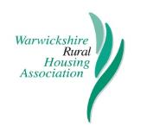
WRHA Board of Management

Terms of Reference

The Board of Management is responsible for the overall running of the housing association and delegating authority where applicable. It is primarily responsible for determining strategy and policy, monitoring the Association’s performance, ensuring that it is financially solvent, effectively governed, and fulfils the delivery of its Mission Statement and values. In accordance with the Rules of the Association, five Board Members or half the Board (whichever is the lower) will form a quorum.

The specific duties of the Board of Management are as follows:

- To meet at regular intervals and consider reports dealing with the Association’s affairs and take appropriate decisions or endorse decisions already taken under delegated authority by Sub-committees and Officers.

- To set up sub-committees and task groups as are necessary, provide them with terms of reference and delegate powers to act upon their recommendations.

- To agree the policy and strategic direction of the Association and monitor its overall performance.

- To review its membership, ensuring that it has an appropriate range of skills and experience and that its meetings are properly conducted and recorded.

- To comply with the principles of Good Governance as set out the National Housing Federation document “Code of Governance – promoting Board Excellence for Housing Associations”.

- Satisfy itself that the Association’s affairs are conducted lawfully and in accordance with accepted standards of performance and propriety.

CORE FUNCTIONS

- The Board shall define and ensure compliance with the values and objectives of the Association.

- Establish a Business Plan to achieve those objectives and review the same on an annual basis.

- Satisfy itself as to the integrity of financial information, approving each year’s budget, business plan and annual accounts prior to publication.

- Establish and oversee an appropriate framework of delegation, and systems of control, and provide assurances on the same to the Regulator.

- Oversee the Risk Management Framework and take key decisions on matters that will, or might, create significant risk for the Association.

- Ensure compliance with the Regulator of Social Housing’s regulatory standards, and regularly review such compliance.

- To periodically review the effectiveness of the Association to ensure the Board of Management maintains high standards of probity in its decision-making.

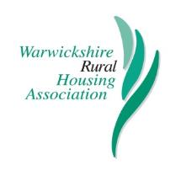

September 2020

Warwickshire Rural Housing Association (WRHA) is seeking passionate individuals, with a commitment to helping sustain rural communities through the provision of affordable housing, to join their Board.

For over 30 years WRHA has provided and managed much-needed affordable homes, enabling people with a local connection to live in the Warwickshire villages they know and love. Their activities significantly contribute to maintaining local services and facilities and safeguarding the future of rural village communities.

The charitable housing association’s Board members play a vital role in strategically guiding the work of the organisation, enabling it to break new ground and consistently deliver on its aims and objectives.

WRHA has a number of vacancies for voluntary Board members interested in helping them continue to make a big impact across the communities they serve and shape the future of specialist rural housing.

The association are particularly keen to hear from people with experience and knowledge of:
- housing development and the planning system
- legal expertise
- PR, media and communications, including social media and digital engagement
- social housing and community engagement.

Applications from people with disabilities and people from an ethnic minority background, are especially welcomed, and WRHA residents and those who live in social housing are actively encouraged to apply.

Ruth Bagley, Chair of Warwickshire Rural Housing Association, commented: “Joining the WRHA Board is an excellent opportunity for people who share our passion to deliver high quality affordable homes for local people and support the sustainability of Warwickshire’s rural villages.

“Our Board helps to ensure that the Association continues to deliver new housing and provide excellent services to our residents.”

If you’d like to find out more about these roles, visit www.warwickshirerha.org.uk to download the recruitment pack and application form or call 0300 1234 009. The deadline for applications is 9am 5th October 2020.

Warwickshire Rural Housing Association (WRHA) is committed to providing affordable homes in rural Warwickshire for local people and families who would not otherwise be able to afford to live within their own communities.

WRHA was established in 1989 and now manages almost 600 homes in 43 rural communities in the county.

APPLICATION FORM FOR MEMBERSHIP
OF THE BOARD OF
WARWICKSHIRE RURAL HOUSING ASSOCIATION

Please return to:

Richard Mugglestone

Email: richard.mugglestone@midlandsrural.org.uk
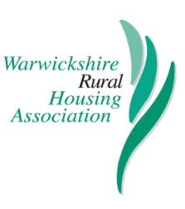

Post: Company Secretary
c/o Warwickshire Rural HA
Whitwick Business Centre
Stenson Road
Coalville
Leicestershire LE67 4JP

Telephone: 0300 1234 009

PRIVATE AND CONFIDENTIAL

Title: |  | First name(s):
Surname:

Home Address:  Post Code: |  | Contact Numbers:  Home:  Work:  Mobile:  Email:
Date of Birth:

How did you hear about the opportunity to become a member of the WRHA Board?:

Work history:

Current and past positions of responsibility in public, private or voluntary sector organisations

Reasons for applying for WRHA Board Membership:

(Please indicate what qualities and skills you feel would be relevant)

Do you have any personal or business relationships with any person or organisation, which may lead to a potential conflict of interest? (If YES, please provide details)

Special Note: In accordance with Homes England / Regulator of Social Housing requirements, Associations are unable to award work to the companies or firms of Board members or their close relatives where they have managerial control of those firms.
References

Please give the names, positions, organisations, address and email details, and telephone contact numbers of two referees:

1. Address  ……………………………………............  ……………………………………............  ……………………………………............  Email  ……………………………………............  Tel No  ……………………………………............ |  |  | Please indicate whether referees can be approached without your prior permission.  YES / NO (delete as appropriate)
2. Address  ……………………………………............  ……………………………………............  ……………………………………............  Email  ……………………………………............  Tel No  ……………………………………............ |  |  | Please indicate whether referees can be approached without your prior permission.  YES / NO (delete as appropriate)
Signature: ………………………………… |  |  | Date: ………………………………..

Equal Opportunities
DIVERSITY MONITORING FORM

The Association wishes to ensure that the composition of the Board of Management reflects the communities that it serves.

In order to meet this commitment, we need to ensure that monitoring arrangements are in place and kept up to date. The completion of this form will help us to do this. Thank you.

Do you consider yourself to have a disability? YES NO

If YES, please state the nature of your disability: ……………………………….

………………………………………………………………………………………………..

Are there any adjustments that could be made to enable you to carry out your duties as a Board or Committee Member more effectively? If YES, please provide details:

………………………………………………………………………………………………..

………………………………………………………………………………………………..

Ethnic or Cultural Origin

I would describe my ethnic origin as:

Asian/Asian British: Bangladeshi Chinese

Asian/Asian British: Indian Mixed: White and Black African

Asian/Asian British: Other Mixed: White and Black Caribbean

Asian/Asian British: Pakistani Mixed: Other

Black/Black British: African White: British

Black/Black British: Caribbean White: Irish

Black/African/Caribbean White: Other

Black/Black British: Other Other (Please specify):

WARWICKSHIRE RURAL HOUSING ASSOCIATION LTD
c/o MIDLANDS RURAL HOUSING
WHITWICK BUSINESS CENTRE
STENSON ROAD
COALVILLE
LEICESTERSHIRE
LE67 4JP

TELEPHONE: 0300 1234 009
EMAIL: enquiries@midlandsrural.org.uk

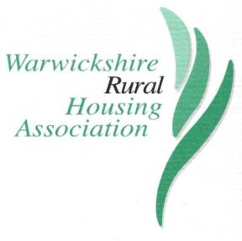

Warwickshire Rural Housing Association Ltd is registered under the Co-operative and
Community Benefit Society with Charitable Status 26636R and with
Homes England No. L3881
A member of the National Housing Federation

